# Ramanujan College

# Name – Tania Bhardwaj

# Roll no – 20201428

# Course – BSc. Comp Science

Computer Networks Practical

Ques1

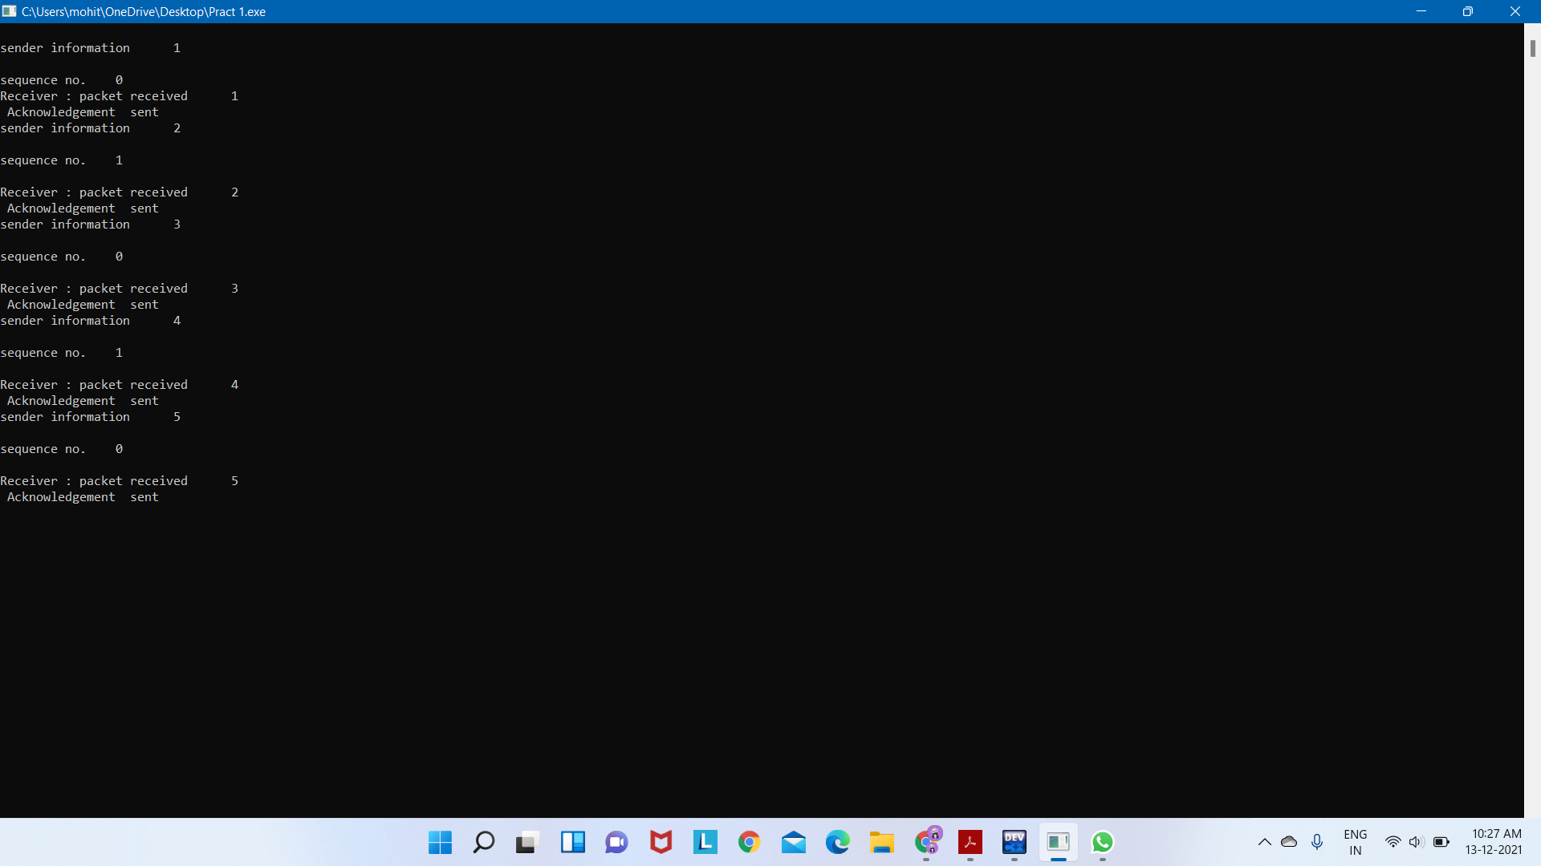

## Design

* **Sender Site** − At the sender site, a field is added to the frame to hold a sequence number. If data is available, the data link layer makes a frame with the certain sequence number and sends it. The sender then waits for arrival of acknowledgment for a certain amount of time. If it receives a positive acknowledgment for the frame with that sequence number within the stipulated time, it sends the frame with next sequence number. Otherwise, it resends the same frame.
* **Receiver Site** − The receiver also keeps a sequence number of the frames expected for arrival. When a frame arrives, the receiver processes it and checks whether it is valid or not. If it is valid and its sequence number matches the sequence number of the expected frame, it extracts the data and delivers it to the network layer. It then sends an acknowledgement for that frame back to the sender along with its sequence number.

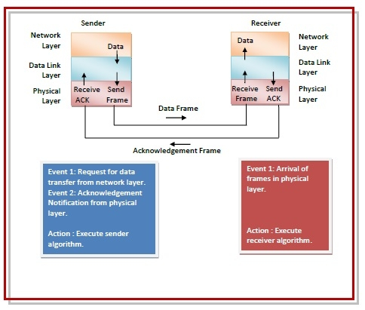

Flow Diagram

The following flow diagram depicts communication via simplex stop – and – wait ARQ protocol for noisy channel −

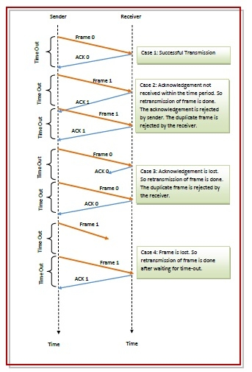

Ques 2

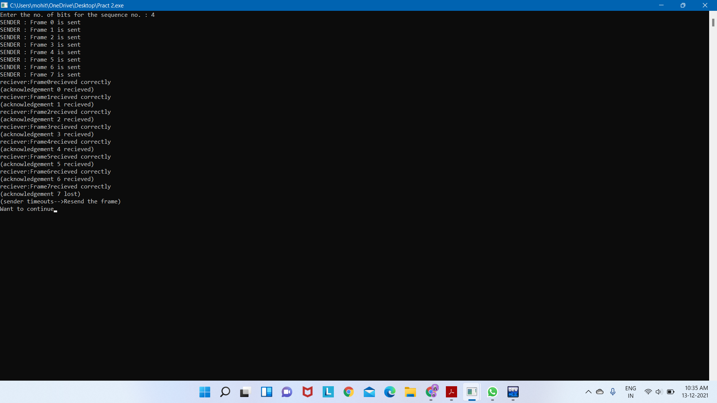

# Selective Repeat Protocol (SRP)

This protocol l(SRP) is mostly identical to GBN protocol, except that buffers are used and the receiver, and the sender, each maintains a window of size. SRP works better when the link is very unreliable. Because in this case, retransmission tends to happen more frequently, selectively retransmitting frames is more efficient than retransmitting all of them. SRP also requires full-duplex link. backward acknowledgments are also in progress.

* Sender’s Windows ( Ws) = Receiver’s Windows ( Wr).
* Window size should be less than or equal to half the sequence number in SR protocol. This is to avoid packets being recognized incorrectly. If the size of the window is greater than half the sequence number space, then if an ACK is lost, the sender may send new packets that the receiver believes are retransmissions.
* Sender can transmit new packets as long as their number is with W of all unpacked packets.
* Sender retransmit unpack packets after a timeout – Or upon a NAK if NAK is employed.
* Receiver ACKs all correct packets.
* Receiver stores correct packets until they can be delivered in order to the higher layer.
* In Selective Repeat ARQ, the size of the sender and receiver window must be at most one-half of 2^m.

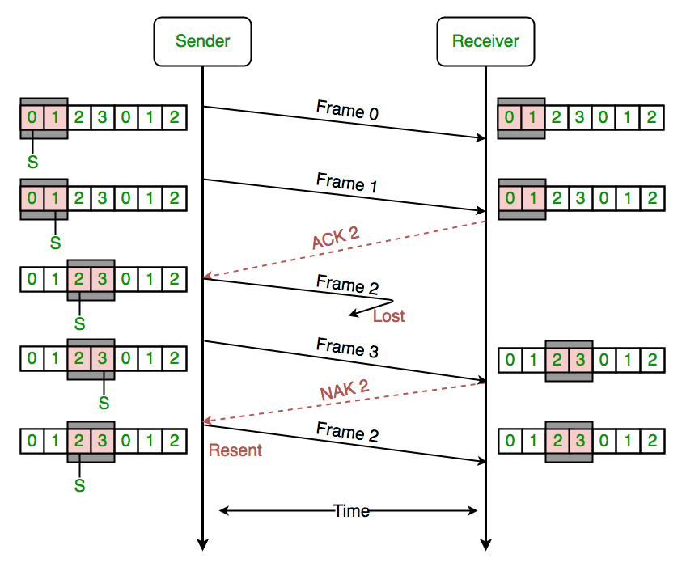

**Figure –** the sender only retransmits frames, for which a NAK is received

Efficiency of Selective Repeat Protocol (SRP) is same as GO-Back-N’s efficiency:

Efficiency = N/(1+2a)

Where a = Propagation delay / Transmission delay

Buffers = N + N

Sequence number = N(sender side) + N ( Receiver Side)